1. **Create a private github repository. And push index.html to it.**

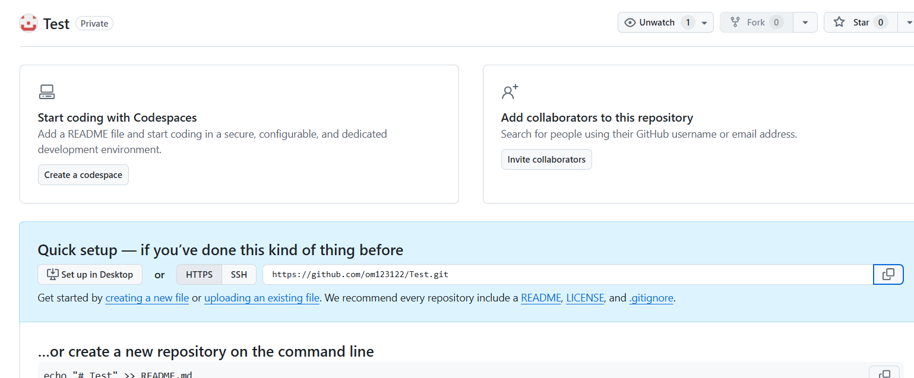

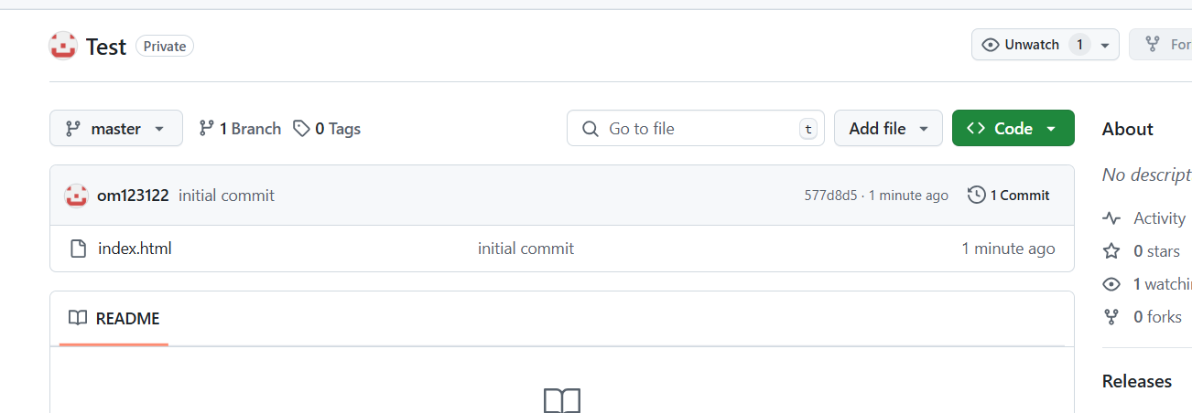

1. **Create Jenkins to install httpd and deploy index.html page and see the output.**

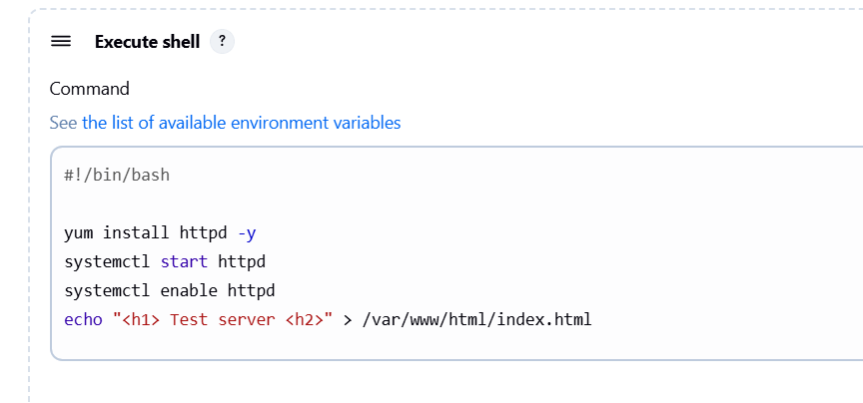





1. **Again push new changes in index.html, verify Jenkins job is deploying the new changes.**

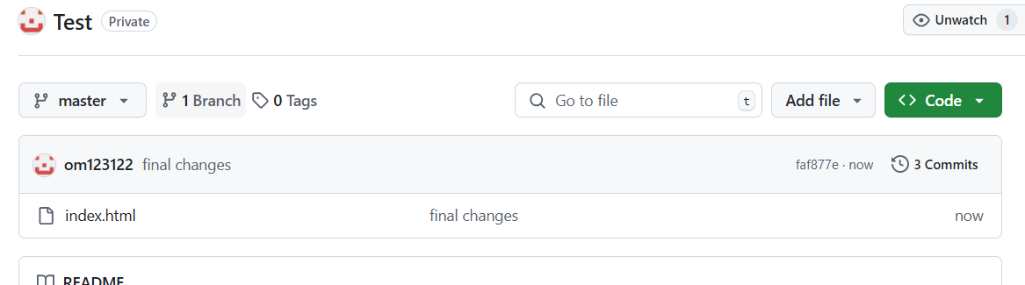

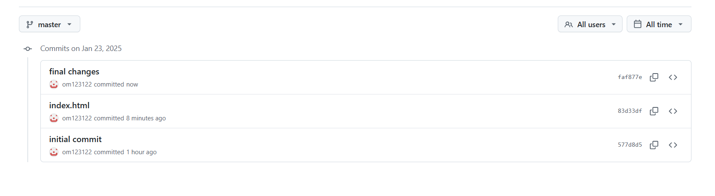

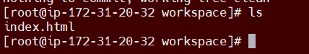

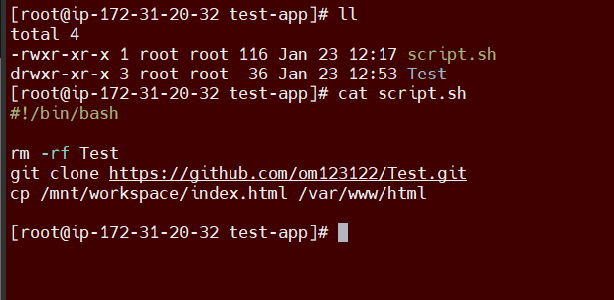

**We can see the changes output in httpd server on web,**

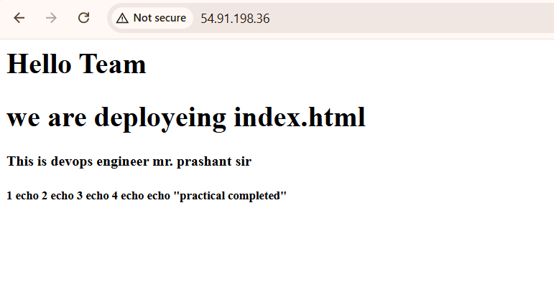

**Also we can able to clone latest private repo using jenkin,**

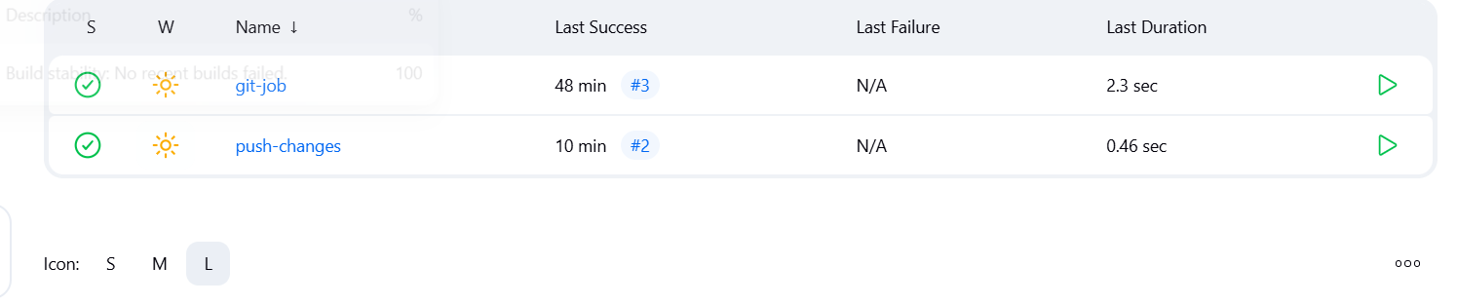

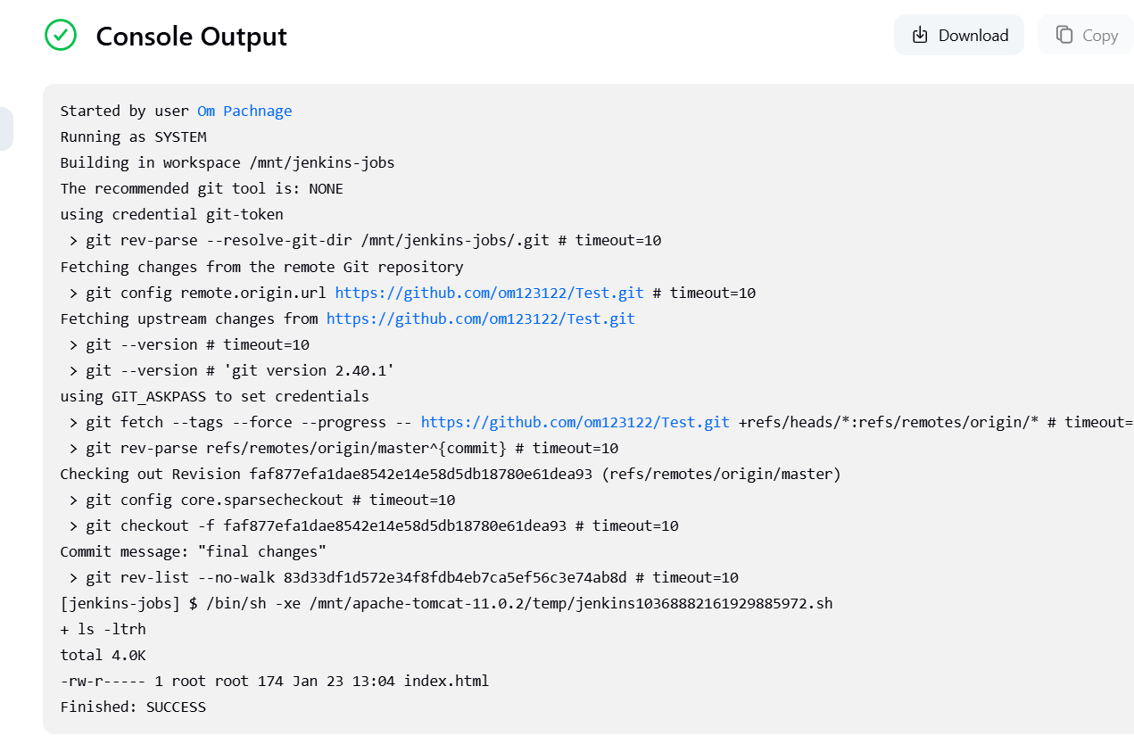

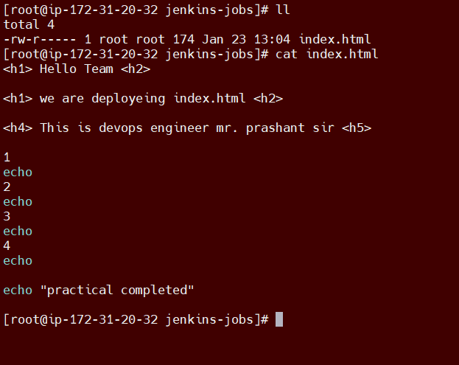

**Httpd – index.html – push latest changes to git hub private repo – see output page on web – finally clone repo from Jenkins and see latest changes .**